Part 1:
Design a program capable of digitizing circles. The system should start with a single window containing a grid of 20x20 points.
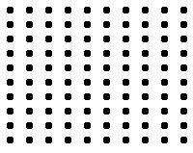
All points should start out grey. The user can then click to place the center of a circle, and then drag to set its radius, similar to various graphics programs. The circle should be drawn on the screen.

When the user releases the mouse button, the program should highlight the points (make them blue) that correspond to the edge of the circle, in a way such that the points could be connected to reconstruct the circle.

Then, two additional circles should be created corresponding to the largest and smallest radius of the highlighted points.

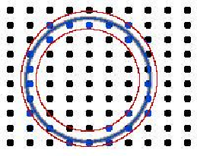
Your solution should be easily executable and well documented. All algorithms should be documented in full, and a synopsis of program execution should be provided.

Part 2:
Now add a button at the bottom of the window called generate. Create a new program, similar to Part 1, which allows the user to toggle points on the grid on and off. When the user clicks the generate button, generate a circle that best fits the highlighted points.

